**Deploying React Web page under Linux and Nginx**

Create an instance in AWS with Linux machine with req security group for REACT(3000):

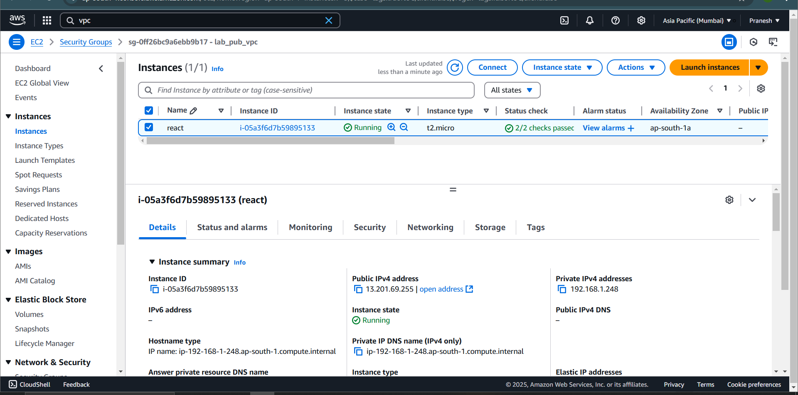

Connect to the Machine and install req package for REACT:

1. Yum install nginx (for web server)
2. Systemctl start/enable nginx
3. Yum install nodejs (need nodejs for react lib to install through npm )
4. yum install npm (node package manager)

Now create a dir where the react files are created with their dependencies:

1. mkdir student
2. Cd student

Now create a REACT APP:

1. npx create-react-app . (react app will create here)
2. npm install react-router-dom (install **react-router-dom** for routing between pages)
3. npm install react@18 react-dom@18 (if any version issues came to downgrade the react version)

To have diff path in web create a files inside /src in react dir:

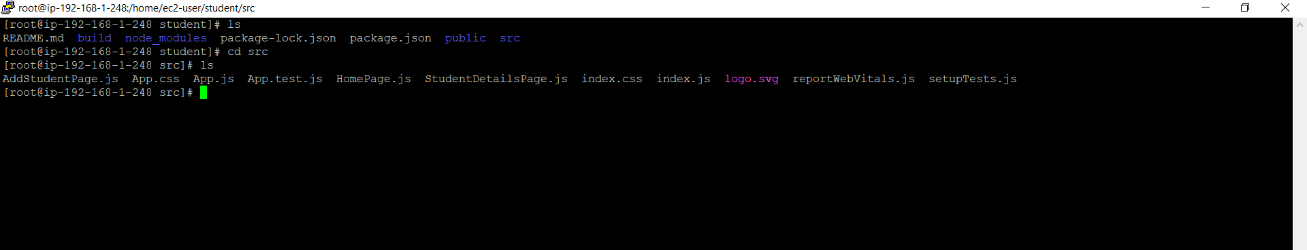

Touch Home.js Studentdetailspage.js Addstudentpage.js

For css styling take App.css file to edit and for import and route all the other path edit in App.js file

Add the codes in corresponding files:

Home.js:

Studentdetailspage.js

Addstudentpage.js

App.js

App.css

After adding all the code BUILD the react app and cp the build file to the Nginx path/usr/share/nginx/html

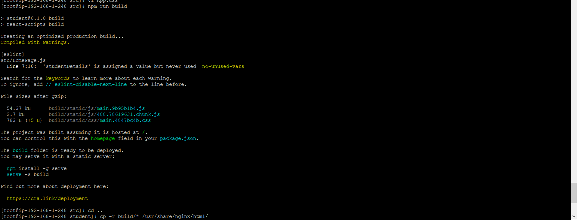

Now restart the nginx : systemctl restart nginx

Now check the react app by giving <public ip> of the instance.

